Backend -🡪 Express and Database is Mongo

We can connect mongo db database using two module

Mongodb

Mongoose :

Controller layer

Router layer

Model layer

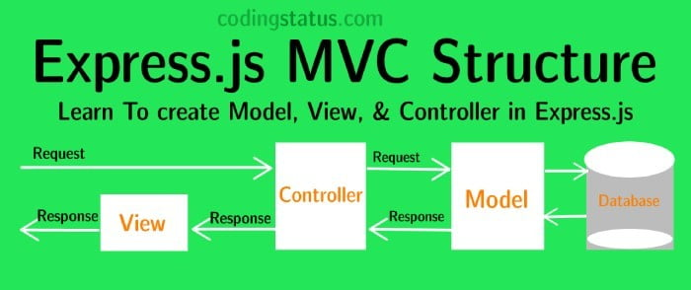

npm install express mongoose

product

id -🡪 PK

pname 🡪

price 🡪

url 🡪

in front end

ng new product-frontend-app

cd product-frontend-app

ng g c product -🡪 component

ng g class product -🡪 model

ng g s product -🡪 service